

CAFÉ BAR SUPERVISOR

Dear Applicant

Thank you for your interest in this post.

Further to your enquiry please find enclosed:

- Job description and person specification
- Equal opportunities form

If you require any of this information in an alternative format, please contact us.

Pound Arts is committed to promoting equality of opportunity in its employment practices. In particular the company aims to ensure that no potential or actual employee receives more or less favourable treatment on the grounds of race, colour, ethnic or national origins, marital or civil partner status, sex, sexual orientation, gender reassignment, age, disability or religious beliefs.

How to apply:

Write a covering letter showing how the points required in the person specification are met, and send with CV to:

Chris Moore, Administration & Business Manager, by email (preferred): admin@poundarts.org.uk

or post to Pound Arts, Pound Pill, Corsham, Wiltshire, SN13 9HX

Deadline for applications is Thursday 5 March, 10am

We will let you know if you have been shortlisted for interview as soon as possible. We are unable to give feedback on unsuccessful applications at this stage, but we are grateful for your application.

I look forward to receiving your application,

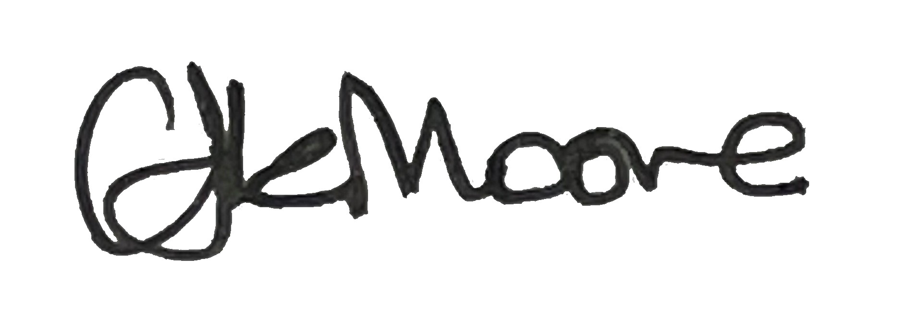

Chris Moore

Administration & Business Manager

THE POUND ARTS CAFÉ BAR
Pound Arts Café Bar is a community interest company, governed by a team of volunteer directors, delivering a high-quality daytime cafe and evening bar to complement the activities of the Pound Arts Centre.
We have a small food preparation area (grill and microwave) but not a full kitchen. A range of items can be heated and presented at the venue. We serve snacks and cakes made by local, independent suppliers. We also operate a bar offering alcoholic and soft drinks. A 2024 inspection rated us 5* for food hygiene.

THE POUND ARTS TRUST LTD
The Pound Arts Trust Ltd is a thriving arts organisation based in Wiltshire, core funded by Wiltshire Council, and is an Arts Council England National Portfolio Organisation. The organisation delivers live performance, visual arts, participatory activities and film across three distinct strands of work:

The Pound is a historic Grade II listed building converted into a 21st century arts centre acting as the hub for the arts in north Wiltshire and beyond, presenting a year-round programme of professional music, theatre, dance, visual arts, film and participatory work. The Pound’s rehearsal and workshop rooms are hired by various community groups and artists, and there are three artists’ studios and a community workshop space. The Pound has a popular fully licensed café bar.

Rural Arts Touring: The rural touring programme for Wiltshire and South Gloucestershire working with volunteers in rural communities across the two areas, to deliver around 60 professional live performances and 20 participatory events each year.

Festivals:
The Blue Sky Festival: A warm and quirky festival of family focused arts events and projects in June. Magic and Mayhem Festival: A delicious and decadent festival of magic, cabaret, jazz, music hall, comedy, burlesque and other oddities in November.

CAFÉ BAR SUPERVISOR

Key tasks of this role are:

- Supervising and motivating the café staff team (approx 8 casuals) and organisation of the staff rota.
- Ensure compliance with all legal and licensing requirements involved in running a café bar.
- Excellent communication with staff and customers.
- Communicating with Pound Arts team to create a café bar offer that complements and enhances the arts centre.
- Ensuring a calm, friendly and welcoming atmosphere that suits the various uses of the café bar in the daytime and evenings.
- Working with Pound Arts Staff to ensure the café bar is financially self-sufficient.
- Managing and ordering stock.
- Working with our local suppliers.
- Identifying and selecting new suppliers for equipment and stock as required.
- Reporting to the CIC Board and contributing to business planning.
- Ensuring we offer a range of options for those with dietary requirements.

See the full job description for further details.

The Pound Arts Trust Limited

Job description

Job title: CAFÉ BAR SUPERVISOR

Job Objective: Deliver the offer of the Café Bar to ensure its profitability, ensuring the highest standards of customer service. Ensure all operational systems are executed in an effective manner and according to best practice and meeting current legislation. Work with the arts centre staff to complement the programming as appropriate. Uphold the conditions of the arts centre’s licence. Supervise the Café Bar team to ensure individuals are working to their best potential.

Nature and Scope: The Café Bar presents a friendly and welcoming environment, as an integral part of the public face of the arts centre.
While receiving guidance and support from both the Community Interest Company Board and The Pound Arts centre Director, the success of the Café Bar will depend on the imagination, initiative and energy of the Supervisor. We are looking for someone with previous experience managing and motivating a team and running a similar facility.

Reporting to: Administration & Business Manager of The Pound Arts centre and the CIC Board

Responsible for: Café Bar Staff / Café Bar Volunteers

Salary: £24,784.50 per annum pro rata where applicable (37.5 hours per week). This post is being advertised as full time, but we are open to job share or other models if they are practical.

KEY ACCOUNTABILITIES

Supervisory role
- Work with the Arts Centre management team to ensure the following:
  - Supervise the team of café assistants to ensure effective team delivery.
  - To train and manage café assistants and volunteers and to draw up weekly rotas to ensure adequate cover for the Café Bar during opening times.
  - Motivate the team to high standards of delivery.

Administration
- To ensure the efficient running of the Café Bar and catering operation in accordance with set procedures and policies.
- To understand and have a working knowledge of all current legislation and best practice pertaining to licensing, health and safety, food safety and be conversant with the rules contained within.
- To order stock and maintain up-to-date, accurate stock control records.
- Manage equipment contracts and ensure equipment is kept in working order, identifying new products and contracts where required
- To maintain up to date records with regard to cleaning and food hygiene and to maintain best practice in this area including our 5* rating at inspection
- To adhere to licencing laws and be willing to take on the role of licensee and designated premises supervisor.
- To adhere to recycling procedures and to contribute towards sustainability efforts.
- To represent the catering team at any necessary meetings.
- To liaise with arts centre programming staff to ensure that the Café Bar responds to the programme as appropriate, planning for specific events in tandem.
- To develop and manage additional Café Bar requirements in external venues, for instance during busy Festival periods.
- To work with the Administration & Business Manager to manage the budgets and finances (including cashing up).
- To uphold the requirements of a Community Interest Company (CIC).
- To report to the CIC Board who oversee the café.
- To prepare information for the payroll as required.
- To develop the Café Bar in line with its business plan and maximise its profitability.

Service
- To provide a welcoming and efficient service to the public, artists, hirers and promoters.
- To develop the Café Bar offer and ambience in keeping with the rest of the arts centre.
- To prepare food and drinks in line with set policies and procedures.
- To collect, clean and store all crockery, cutlery, glassware and other such catering equipment. Maintain an inventory of such.
- To promote a creative selection of items on offer.
- To be dressed to the appropriate standard and punctual.
- To ensure that at all times the highest standards and approach is taken by all staff with regards to food allergens and intolerances. Ensure this is right every time.

Health and Safety
- To ensure that all areas are operating within the current regulations relating to Health and Safety at Work, Food Handling and Hygiene Regulations, restrictions on the Sale of Alcohol, certain age-restricted products and relevant parts of the Shops Acts.
- To upkeep the expected cleanliness standards within the catering areas while following company policies and procedures.
- To be conversant in the latest developments in Health and Safety pertaining to public buildings and act upon any issues that are raised by staff by liaising with the Administration & Business Manager.
- To produce a management report for and participate in the bi-monthly CIC management board meetings, and participate in and contribute to staff meetings and ensure awareness of the content of minutes arising from such meetings.

This job description is not exhaustive and is open to review following discussion with the job holder. As cafe duties permit the post holder will be expected to undertake other tasks associated with the overall management of The Pound arts centre's business as directed by the CIC Board or Trustees of The Pound arts centre.

Person Specification
EXPERIENCE, KNOWLEDGE AND SKILLS
 | Essential | Desirable
Experience & knowledge | - Experience of working in the catering industry  - Experience and knowledge of best practice customer service  - Demonstrable experience of leading and managing staff  - Demonstrable experience in motivating a frontline team  - Understanding of stock rotation and ordering  - Experience identifying and selecting suitable suppliers  - A working knowledge of budgets and budgetary control  - Ability to use a till, and cash up to a level suitable for the daybook  - A working knowledge of Health and Safety requirements  - A detailed practical knowledge of legislation and good practice that must be complied with when operating a café bar, including alcohol sales, food allergens and intolerances, and food hygiene  - Level 2 Food Hygiene and Safety for Catering certificate | - Managing contracts with equipment and stock suppliers  - Personal license holder  - Award for Licensed Premises Staff  - Demonstrable experience of leading and managing volunteers
Skills | - Food preparation  - Management and organisational skills including producing rotas  - Ability to work on own initiative without supervision  - Interpersonal skills - able to develop good work relationships, enjoy meeting and working with people at all levels and from diverse walks of life  - Calm, and able to work under pressure and in a fast changing and busy environment, and support others in this to ensure calm and effective delivery  - Computer literate especially in Word and Excel and use of web ordering  - Personable and welcoming, with an ability to establish a rapport with the public and co workers | - Good marketing skills, including the use of social media  - Developing and delivering successful new areas of sales within a café style environment  - Understanding how to set prices to ensure cost effective operation and maximise income

Level 2 Food Hygiene and Safety for Catering certificate is required. If the successful candidate does not already hold this, you must be willing to obtain it before taking up the post.
A DBS check will be undertaken.

OTHER INFORMATION

All employees have a duty under the relevant Health and Safety at Work laws to ensure their working environment is kept free of hazards that may prove injurious to themselves, their colleagues and all those engaged in cafe business as well as any visitors

All employees have a duty to comply with The Pound arts centre's Equal Opportunities Policy in their contacts with other staff, customers and visitors.

All employees have a duty to comply with The Pound arts centre's Safeguarding Policy in their contacts with other staff, customers and visitors.

The post holder will maintain appropriate customer confidentiality information and will be expected to comply with all aspects of the Data Protection Act.

TERMS AND CONDITIONS

Title of Post: Café Bar Supervisor

Working hours: 37.5 hours per week, or part-time hours as agreed on appointment. The job holder will be expected to work flexibly reflecting the operating hours of the Café Bar, including evenings and weekends. Hours will likely fall during the following periods: 9:00am to 11pm Monday to Saturday, with some variation depending on events. One of the duties of the Supervisor is to organise the rota, including placing themselves within this appropriately.

Holidays: For full time staff, the annual holiday entitlement is 28 working days
including bank holidays. For part time staff, the holiday entitlement
is pro rata. In addition, all staff are given the three days off between Christmas and New Year, and a day off on or near their birthday as operations allow.

Salary: £24,784.50 per annum (pro rata).

Salaries are paid monthly in arrears by BACS on the final working weekday of each month.

NEST pension scheme

Option to use RewardGateway our staff benefits website

Probation: There is a three-month probationary period which will be followed by a review meeting.

Notice period: Two months’ notice is required.

Equal Opportunities Pound Arts is committed to promoting equality of opportunity in its employment practices. In particular the company aims to ensure that no potential or actual employee receives more or less favourable treatment on the grounds of race, colour, ethnic or national origins, marital or civil partner status, sex, sexual orientation, gender reassignment, age, disability or religious beliefs.

